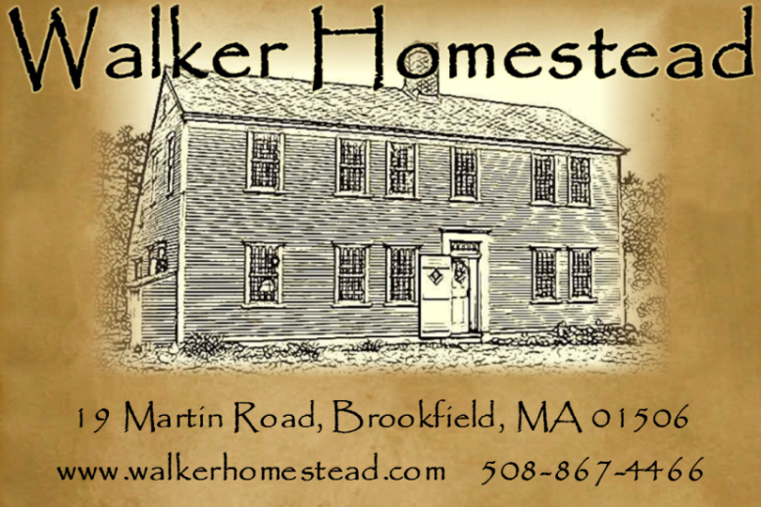
Christmas Ornament & Garland Workshop with Kris Casucci ~

WALKER HOMESTEAD is known for our garlands and handmade Christmas ornaments! Join us for a workshop making Christmas ornaments and garlands from natural materials such as nuts, gourds, dried fruits, flowers, spices and pods. All materials and a seasonal luncheon are provided with your fee. Students will take home a garland and ornaments which they create.

Kris Casucci has been gardening at Walker Homestead for 30 years. She is an antique dealer, gardener and contributing author for "A Simple Life" magazine. In a prior life, she worked as a title examiner, researching early land records for surveys and title issues. She recently retired from selling real estate in order to pursue her business, Walker Homestead, together with her husband, Paul.

Date: Saturday, December 12, 2015 9:30 a.m. – 3:30 p.m.
Place: Walker Homestead, 19 Martin Road, Brookfield, MA 01506
Cost: $85 per person includes instruction, materials and a seasonal luncheon.

Menu
Spinach & Feta Stuffed Mushrooms
New England Beef Stew
(vegetarian offering is available)
Sweet Potato Biscuits
Walker Homestead’s Famous Apple Crisp
Hot or Cold Cider
Hot or Cold Tea
Coffee

Schedule
9:30 a.m. – Coffee & Introductions
10:00 a.m. – Class
12:15 - Break
12:30 – Lunch
3:30 – Visit our shop & questions

REGISTRATION FORM

Event: Christmas Ornament & Garland Workshop~
Saturday, December 12, 2015 9:30 a.m. – 3:30 p.m.

Name: ___________________________________________________________________

Address: _________________________________________________________________
__________________________________________________________________
__________________________________________________________________

Phone: ____________________________________________________________________

E-mail: ____________________________________________________________________

Please let us know if you have any special dietary needs (vegetarian & gluten free options are available, notify us of any food allergies): _______________________________________________
_____________________________________________________________________________________
Event cost: $85

(credit cards are accepted, use form below)
If paying by credit card:
Name on card: __________________________________
Card Number: ___________________________________
Expiration date: _____________ 3 digit code on back: ___________
Zip code from billing address: _____________________

Please mail this form, together with payment, to:

Walker Homestead
19 Martin Road
Brookfield, MA 01506

Thank you!

